Systems of Linear Equations Project

Introduction
Systems of linear equations are a useful way to solve common problems in different areas of life. One of the most powerful ways to use them is in a comparison model where two similar situations are compared side by side to determine which one is better. In this project, you will be choosing between two real life situations and then using systems of linear equations to decide what to buy. The two situations are:

1. Cell phone plans, comparing monthly fee and price per text message.
2. Two cars, comparing the base price (the cost of the car) and the cost of driving the car.

Cell Phone Plans  Situation: You have graduated from high school and moved away to college. Your parents have decided that it’s time for you to pay for your own cell phone. You have to stick to a strict budget and plan to spend no more than $75 per month. Now you need to determine whether you should go with a plan that costs more per month but charges less per text message or a cheaper plan that charges more per message.  Assignment: Gather information from Sprint and AT&T through their websites. NOTE: You cannot purchase unlimited Data for this exercise. Then write a system of linear equations for the two plans and create a graph. Use the methods we have been studying to determine which plan is better based on the number of text messages you send per month. | Car Comparison  Situation: You just got your first job and have decided that it’s time to buy a car. You’ve narrowed it down to either a  2014 Ford Mustang or a 2014 Chevy Malibu(hybrid).  (Use this site http://www.edmunds.com/ to find more options for your vehicle choice ) The malibu costs a bit more but gets better gas mileage, so will cost less to drive. NOTE: For simplicity, let’s say gas costs 2.5 $ per gallon. Determine how long it will take until you’ve spent more on the Mustang than you would have on the Malibu to make your decision.  Assignment: You will gather information (price of the car and the miles per gallon) for each of the cars. Then you will write a system of linear equations for the two cars and create a graph to determine which will be the better buy.

Project Details
Today, you will decide which project you want to do. After you decide on a project, you will need to:
1) Collect the data.
2) Write the system of linear equations and a word problem once the data has been collected.
3) Use the methods we have been studying (graphing and solving algebraically) to find the solution to the written system.
4) Designing the final display of the project on your graphic organizer!

Graphic Organizer for your (Comparison of Cars) project:

Vehicle Images/ Picture  Key Features:  - Base Price:  - MPG:  - Year:  - Model:  - Type:  - etc…  Variables/Equations:  Let :  - The price of gas be : $...  - The total amount of money (y)  - The number of miles driven (x)  Equation:  The total price cost, after driving x number of mile:  Total price = Original price + gas prices * # of mile  y = mx + b  Graph  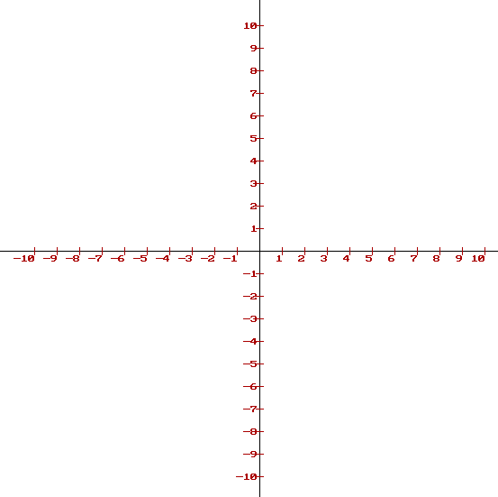 | Vehicle Images/ Picture  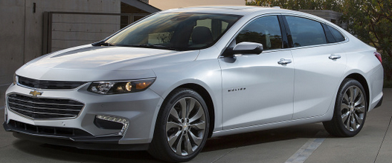  Key Features:  - Base Price:  - MPG:  - Year:  - Model:  - Type:  - etc…  Variables/Equations:  Let :  - The price of gas be : $...  - The total amount of money (y)  - The number of miles driven (x)  Equation:  The total price cost, after driving x number of mile:  Total price = Original price + gas prices * # of mile  y = mx + b  Graph
Break-Even point:
Finding the # of miles needs to be driven for the two car to cost the same:
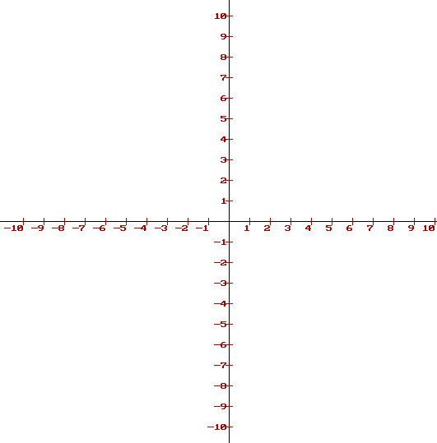

Substitution Method.
Equation1:
Equation 2:

Elimination Method:
Equation1:
Equation 2:

Conclusion

